1. Watch terraform-05 video.

======= Watched ================

1. Execute the script shown in video.

Terraform apply –all-approve (this command is used to without asking yes permission to when terraform apply execute )

Creating s3 bucket using s3 resource

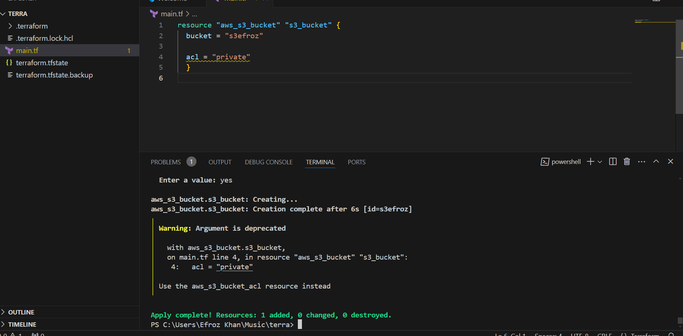

Out of s3 bucket created

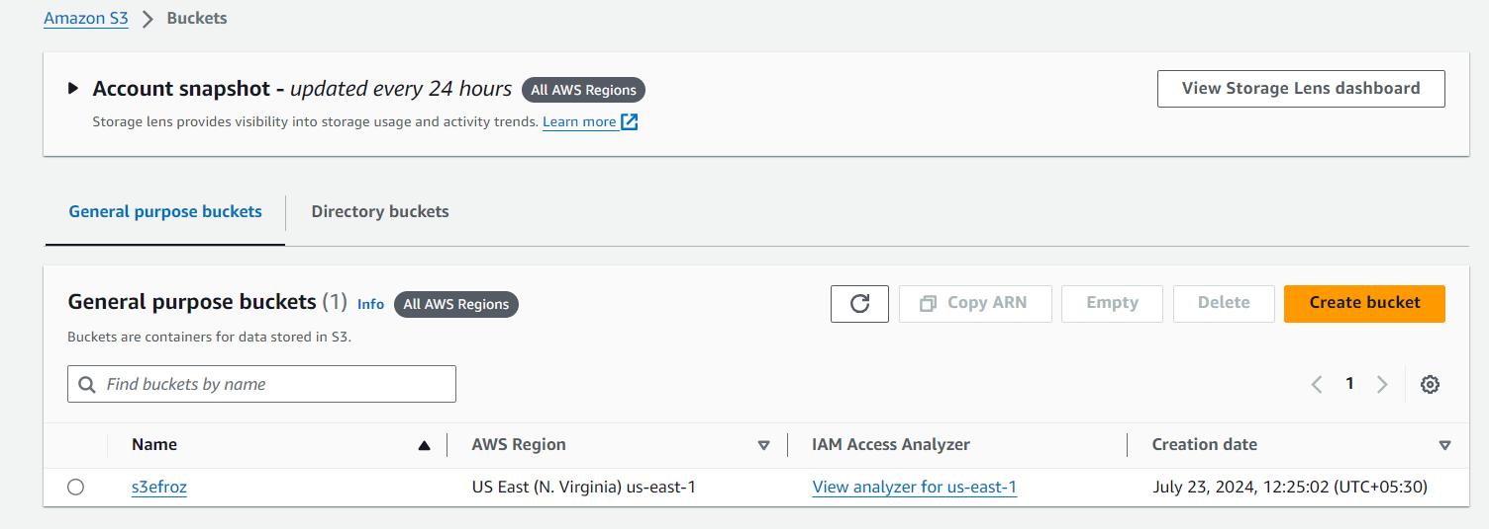

Creating S3 bucket, dynamoDB and S3 as backend for terraform.tfstate file:-

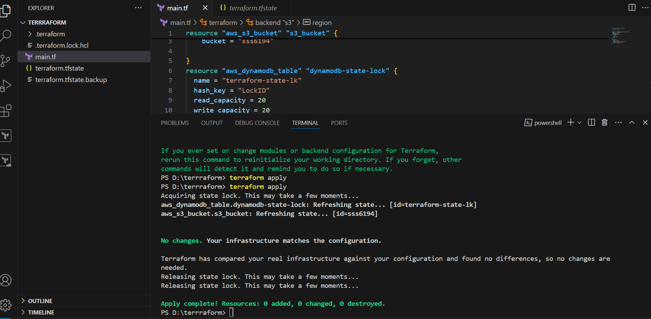

resource "aws_s3_bucket" "s3_bucket" {

    bucket = "sss6194"

}

resource "aws_dynamodb_table" "dynamodb-state-lock" {

  name = "terraform-state-lk"

  hash_key = "LockID"

  read_capacity = 20

  write_capacity = 20

  attribute {

    name = "LockID"

    type = "S"

  }

}

terraform {

  backend "s3" {

    bucket = "sss6194"

    dynamodb_table = "terraform-state-lk"

    key    = "terraform.tfstate"

    region = "us-east-1"

  }

}

S3 output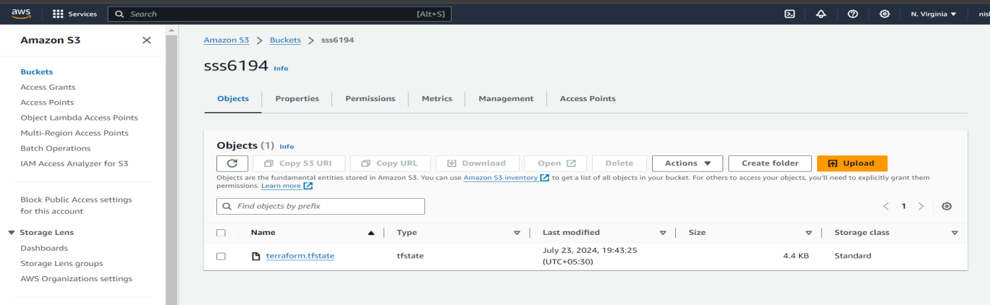

DynamoDB output

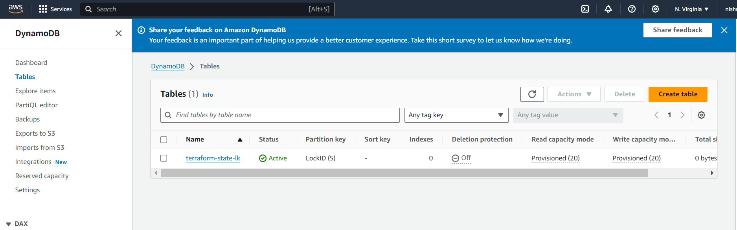

**Terraform** **Provisioner**:-

Creating Ec2 instance using resource

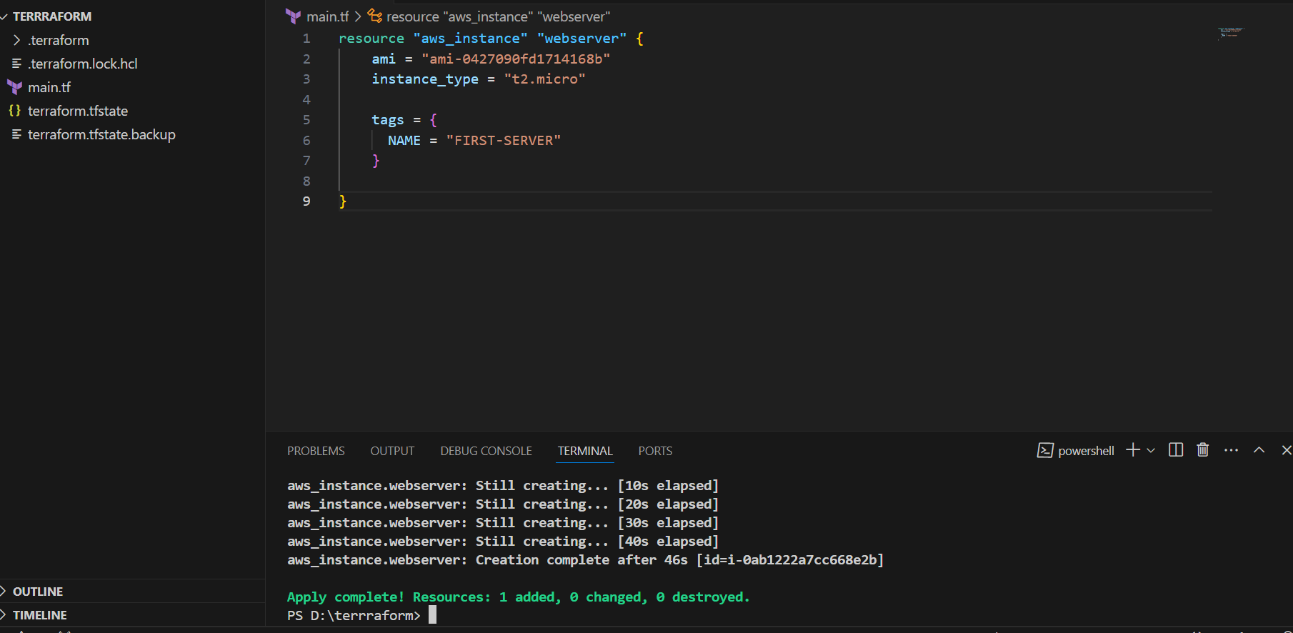

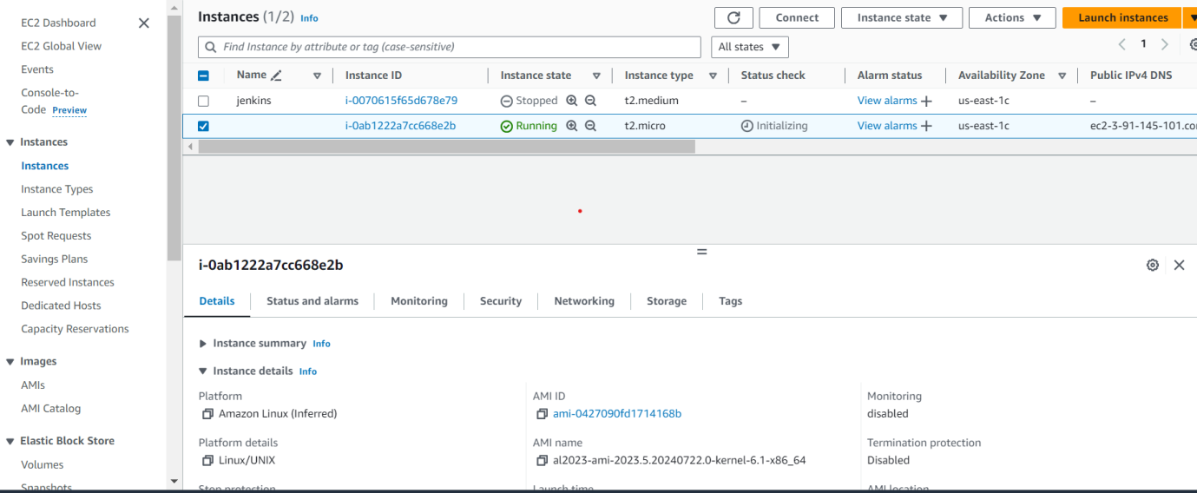

Remote Provisioner Example:

Example of Local Provisioner:-

provider "aws" {

  region = "us-east-1"

}

resource "aws_instance" "test-server" {

  ami           = "ami-0427090fd1714168b"

  instance_type = "t2.micro"

  provisioner "local-exec" {

    command = "echo ${self.public_ip} Created! > public_ips.txt"

  }

  tags = {

    Name = "TestServer"

  }

}

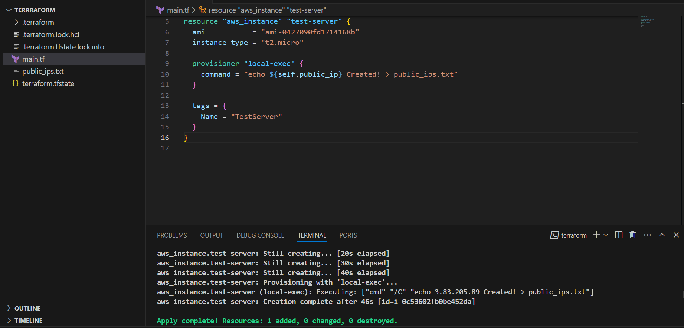

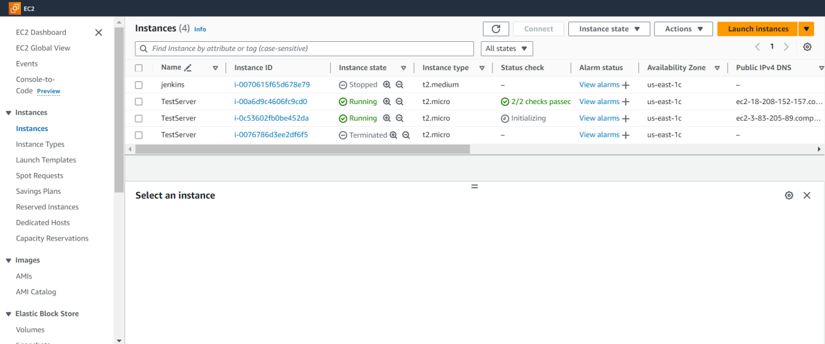

We can use local provider after creating/destroying respource.

**Terraform provisioner behaviours**:

1) Create at the time creating resource (Default)

2) create at the time of destroy in resource (when = destroy)

3) on_failure = fail --> to create the resource if the script gets failed.(But terraform will mark the reource as tainted)

4) On_fail = continue --> to create the resource and ignore the changes.

After destroy we need to add when condition in provisioner.

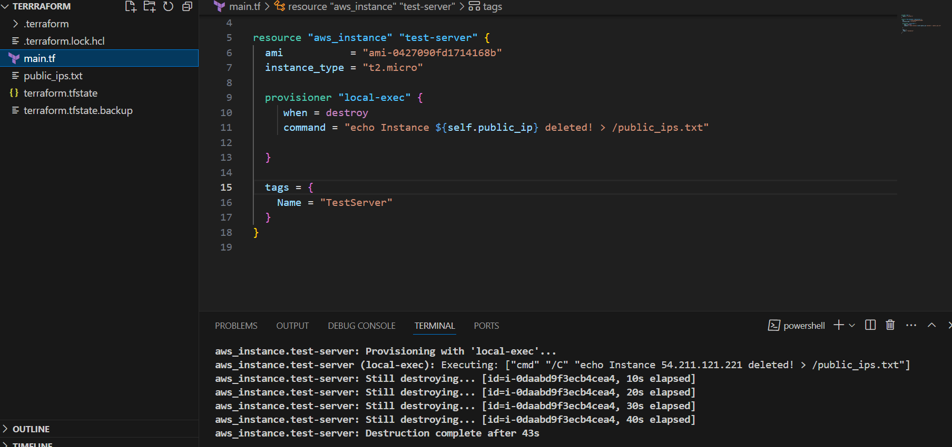

**Terraform taint and untaint:-**

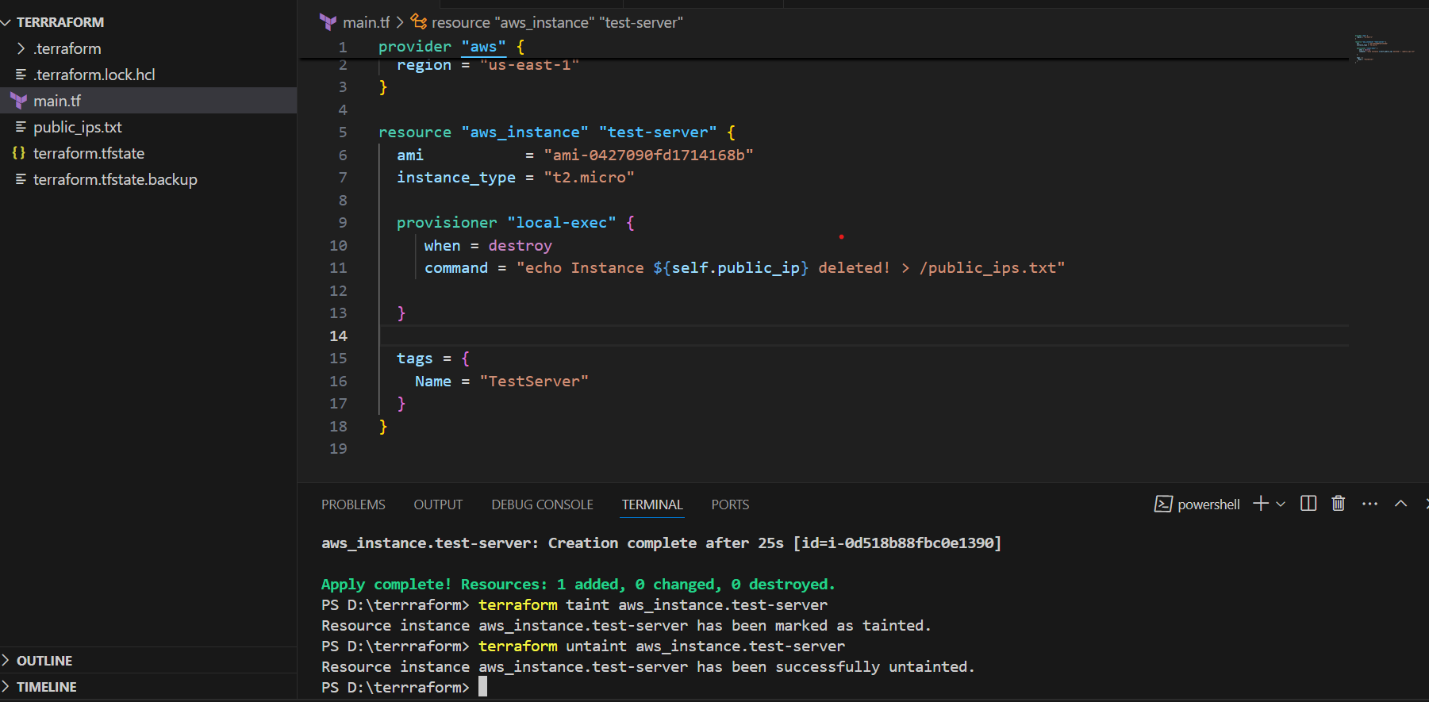

**Debugging:-**

Terraform provides 5 levels of logs:

* INFO
* WARNING
* ERROR
* DEBUG
* TRACE

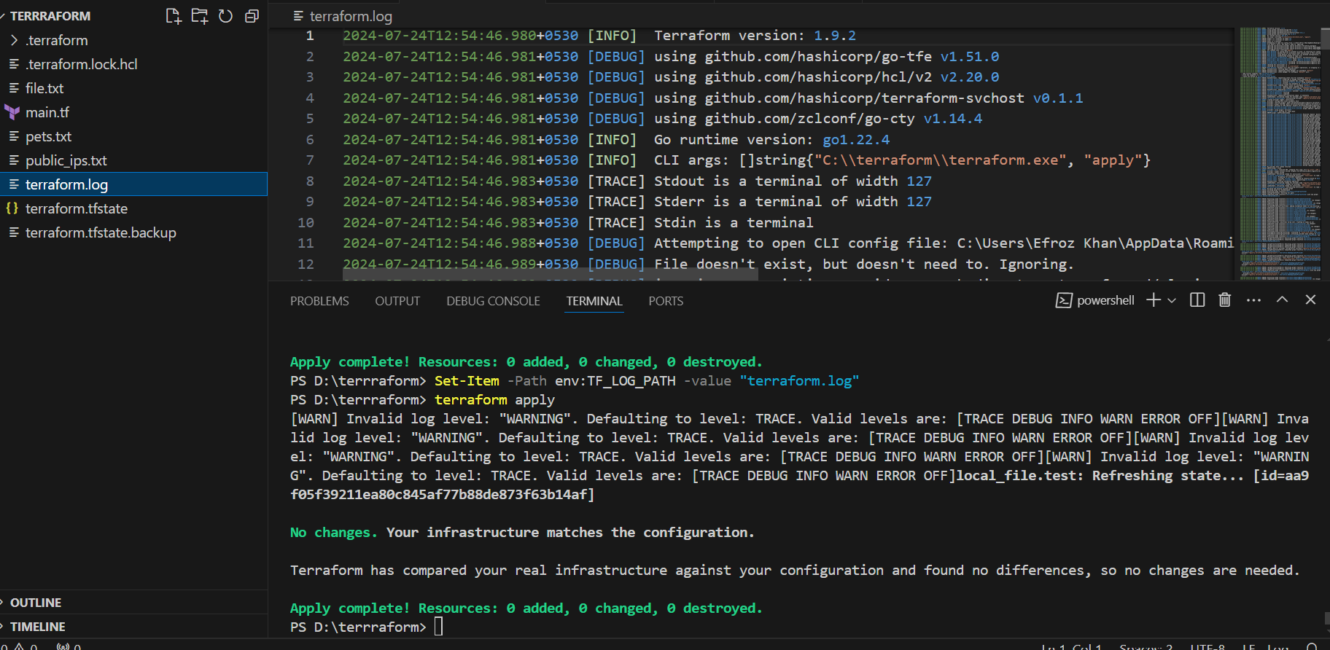

Here we storing logs in terraform.log floder by using below commands

Set-Item -Path env:TF_LOG_PATH -value "terraform.log"

**Terraform import:-**

Terraform import is used to import the existing infrastructure in terraform state file.

Once import is done then we can be able to create/delete and manage the infrastructure.

In order to import any resource we need to write the resource details in configuration file.

terraform import aws_instance.<name> instance_id

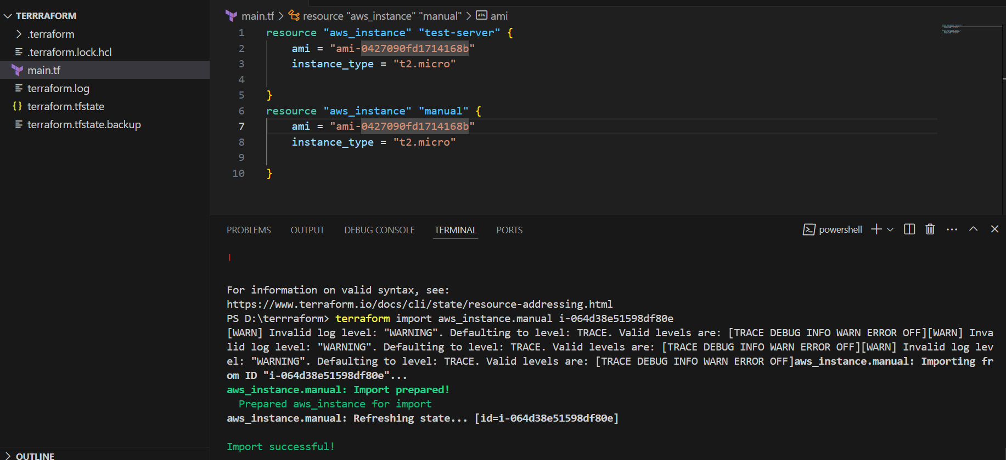

1. Create one ec2 instance with httpd installed using terraform script.
2. provider "aws" {
3. region = "us-east-1"
5. }
6. resource "aws_instance" "task2" {
7. ami = "ami-0427090fd1714168b"
8. instance_type = "t2.micro"
9. key_name = "aws"
10. tags = {
11. Name = "instance"
12. }
13. user_data = <<-EOF
14. #!/bin/bash
15. yum update -y
16. yum install httpd -y
17. systemctl start httpd
18. systemctl enable httpd
19. EOF
20. }

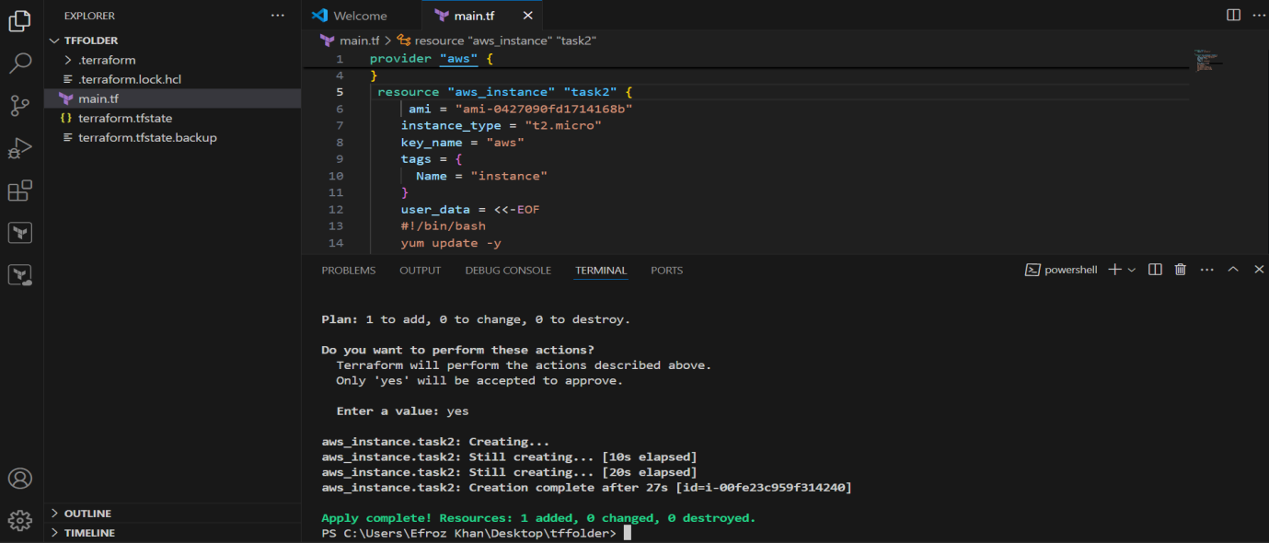

**Out put:-**

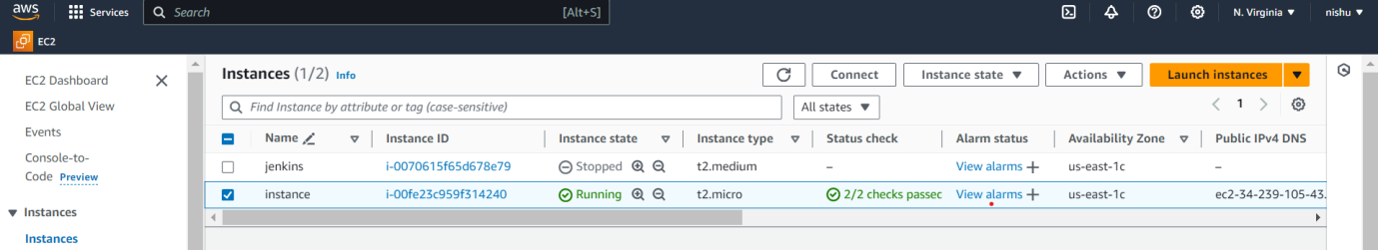

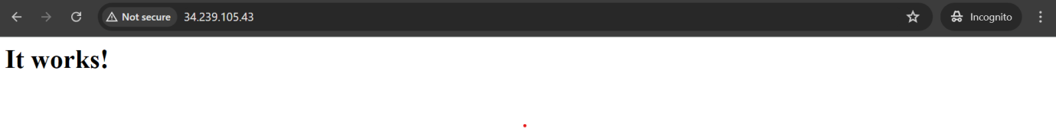

1. Setup s3 as backend to the task 3.
2. terraform {
3. backend "s3" {
4. bucket = "bucket-61946194"
5. dynamodb_table = "ec2-state-lock"
6. key = "terraform.tfstate"
7. region = "us-east-1"
9. }
10. }

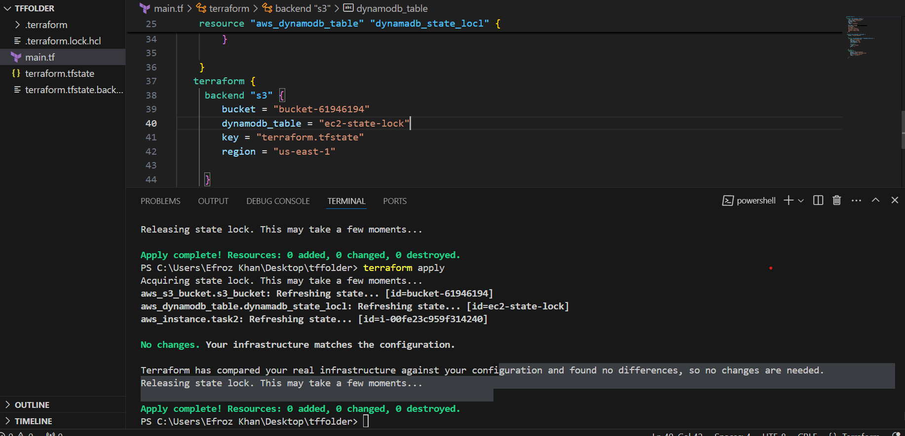

Out put:-

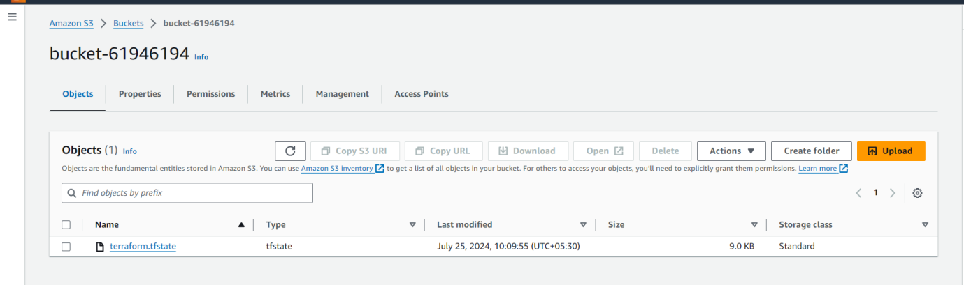

1. Setup dynamo db locking for task3.

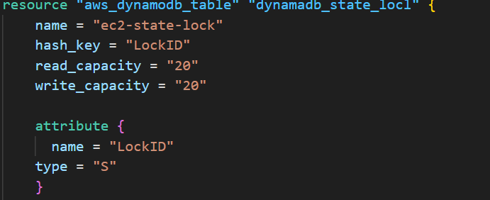

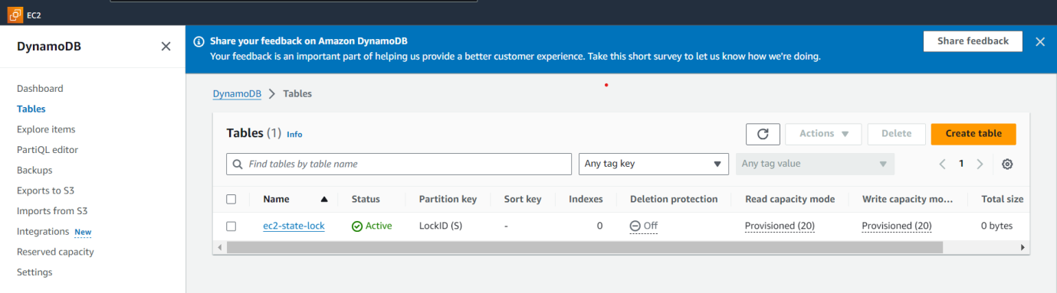

1. Watch terraform-06 video.

**Watched**

1. Execute the script shown in video.

Terraform module:-

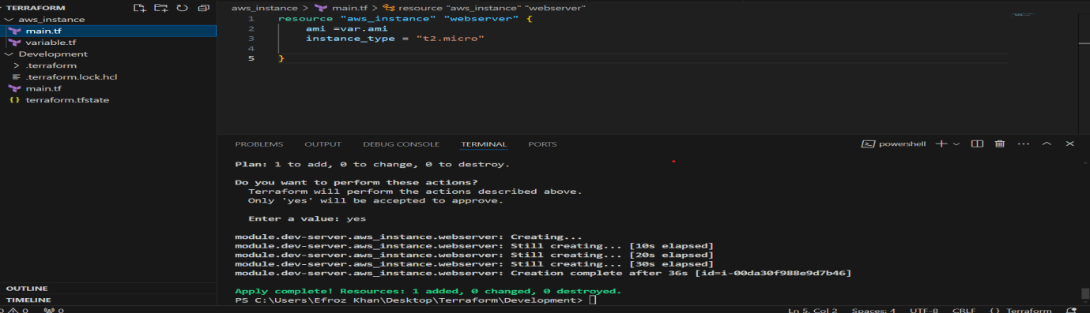

Terrafrom workspace:-

terraform workspace new projectA --> to create a workspace names projectA

terraform workspace list --> to list the workspaces available

terraform workspace selecr projectA --> to swtich to specific workspace

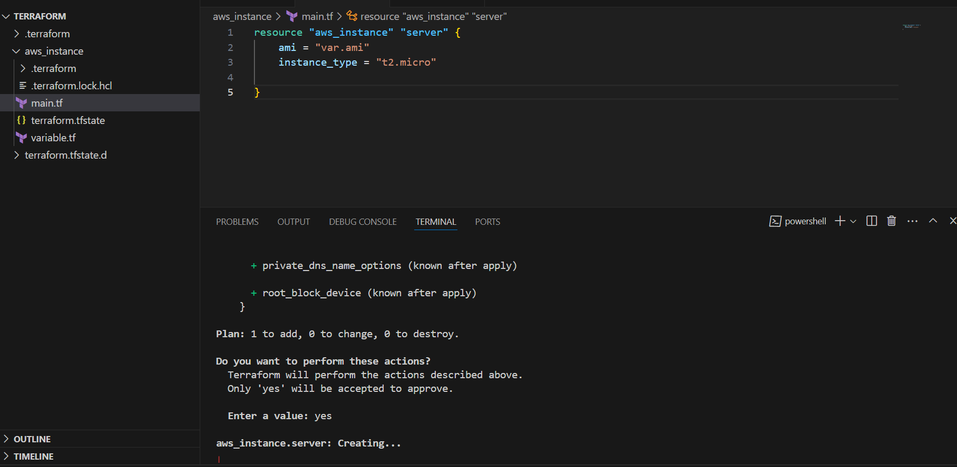

1. Provision ec2,s3 and vpc using Terraform modules.

**EC2 Provision using Terraform:-**

1. provider "aws" {
2. region = "us-east-1"
3. }
4. resource "aws_instance" "example" {
5. ami = "ami-0427090fd1714168b"
6. instance_type = "t2.micro"
7. key_name = "aws"
8. tags = {
9. Name = "instance"
10. }
12. }

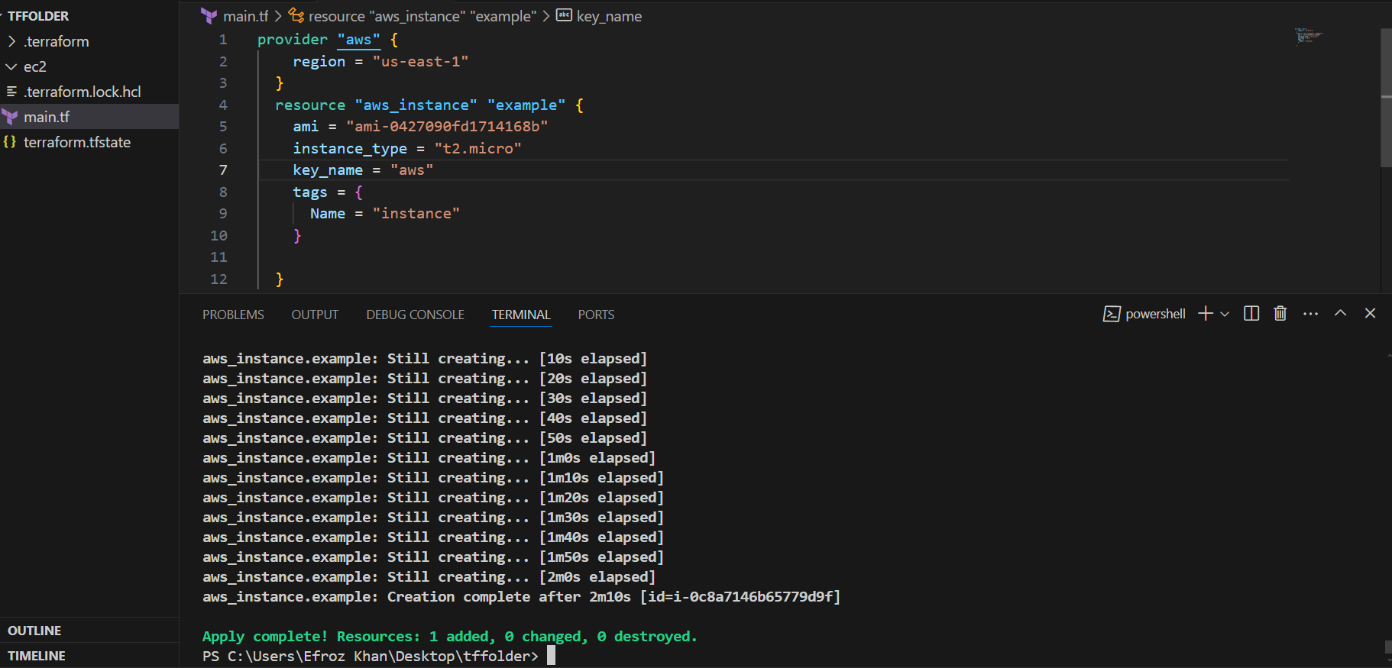

**S3 Provision using terraform** :-

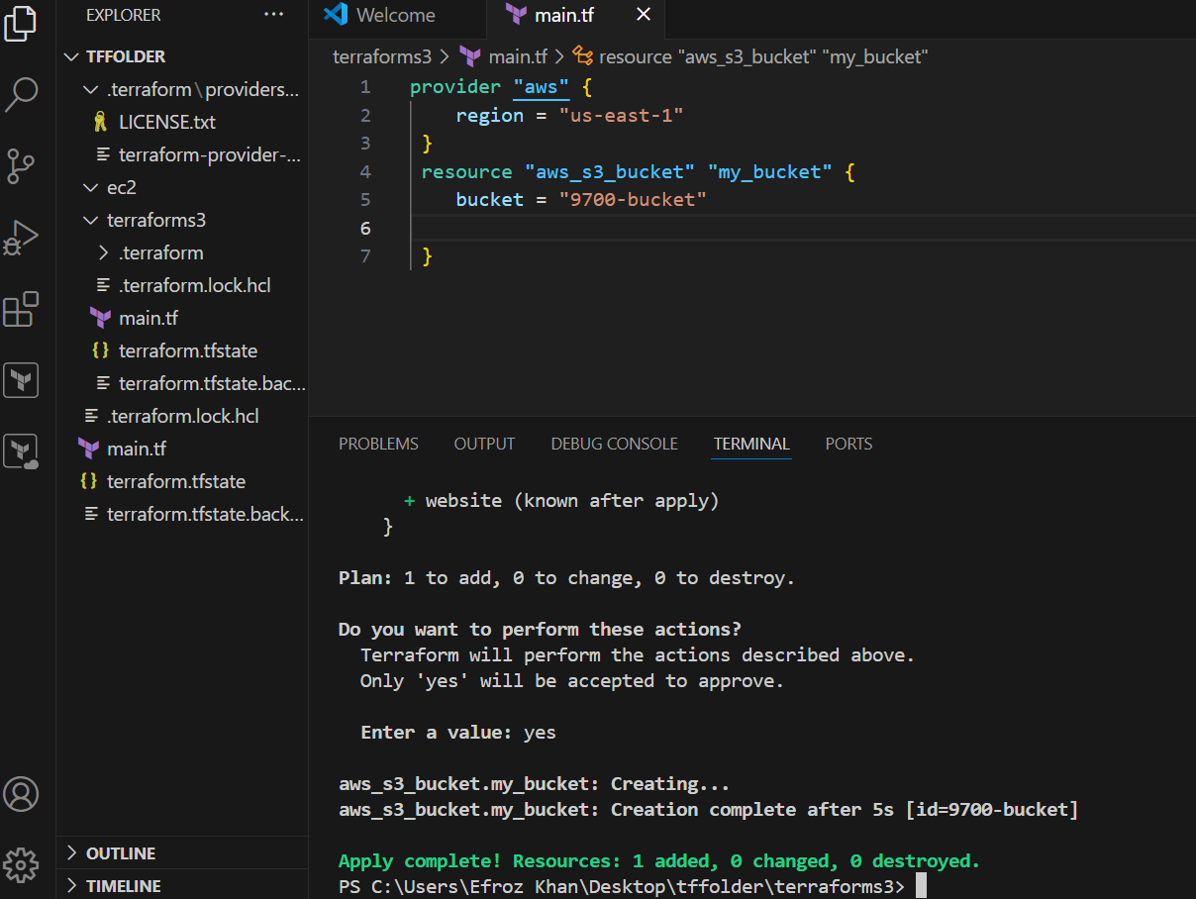

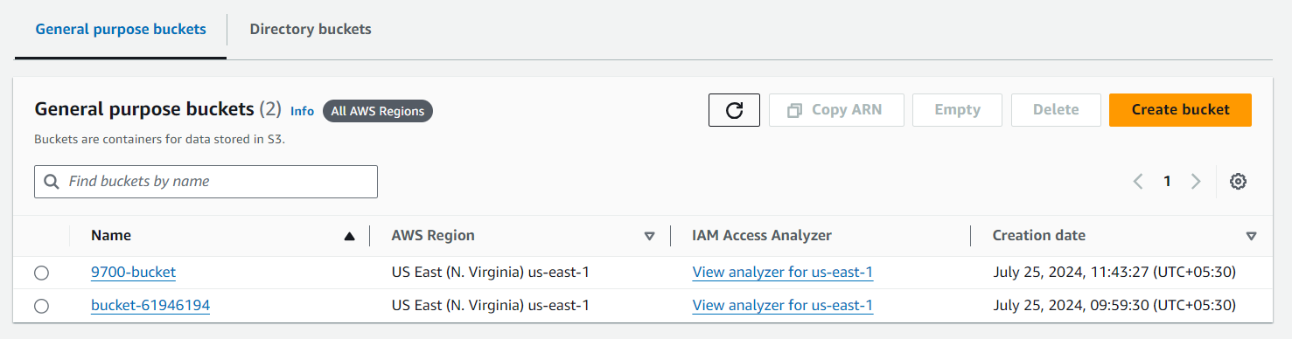

**VPC Provisioning:-**

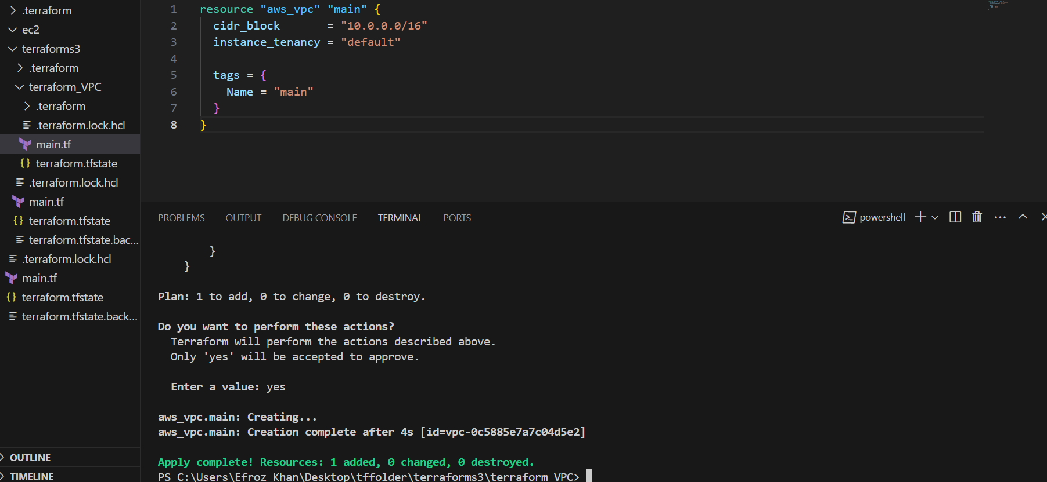

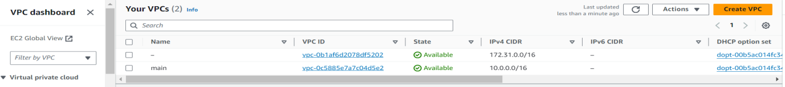

1. Provision ec2 for 3 different environments (Dev, Staging and Prod) using terraform

workspaces.

**Dev workspace Environment:-**

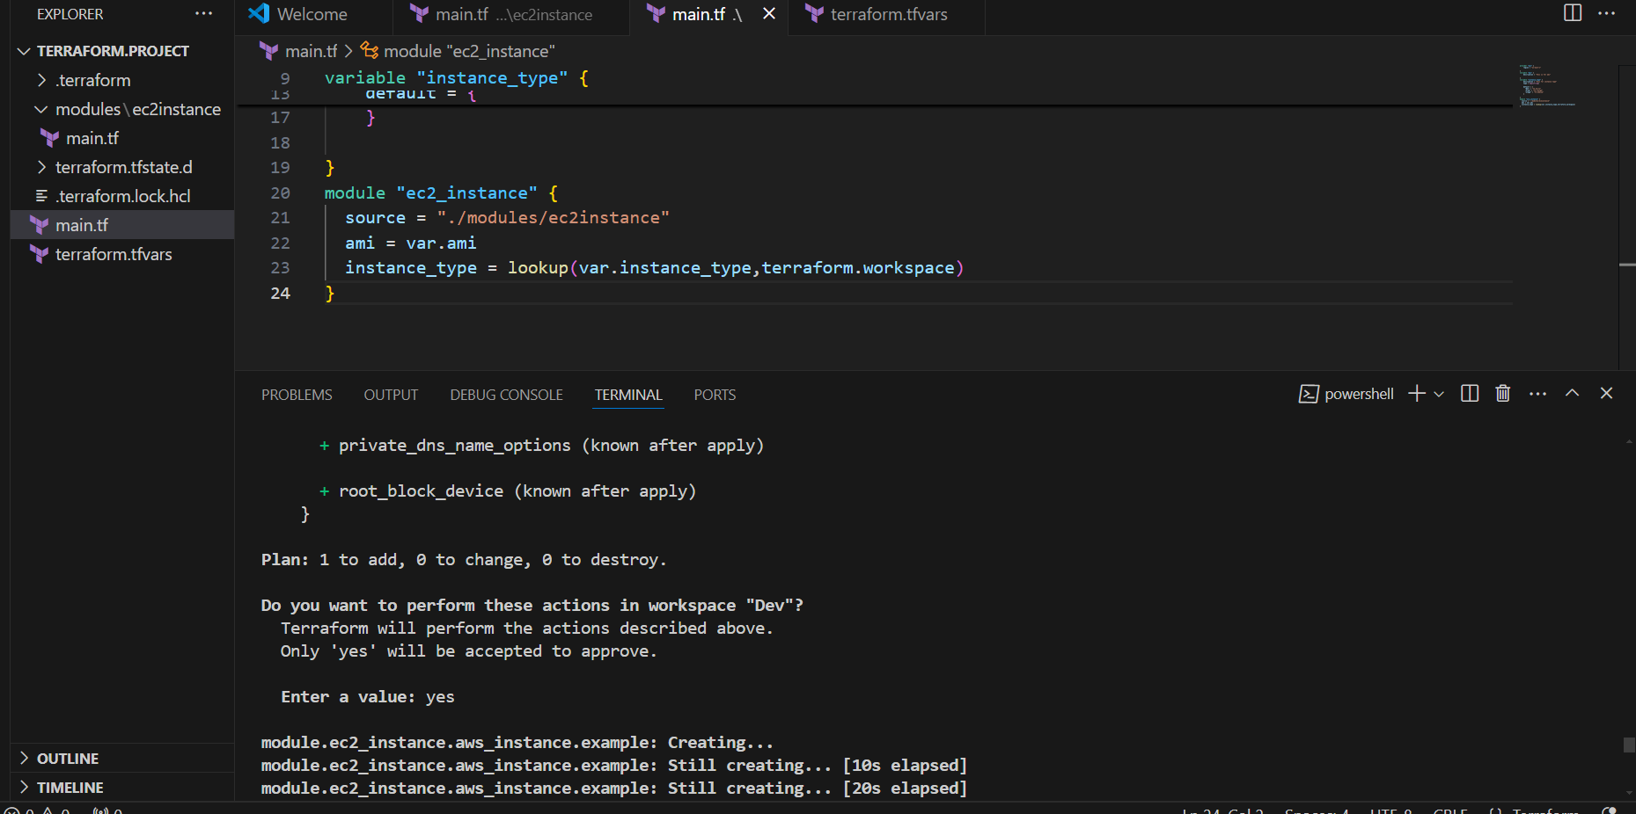

Dev environment output:-

C:\Users\Efroz Khan\Pictures\Screenshots\Screenshot 2024-07-25 175652.png

**Stage Workspace Environment:-**

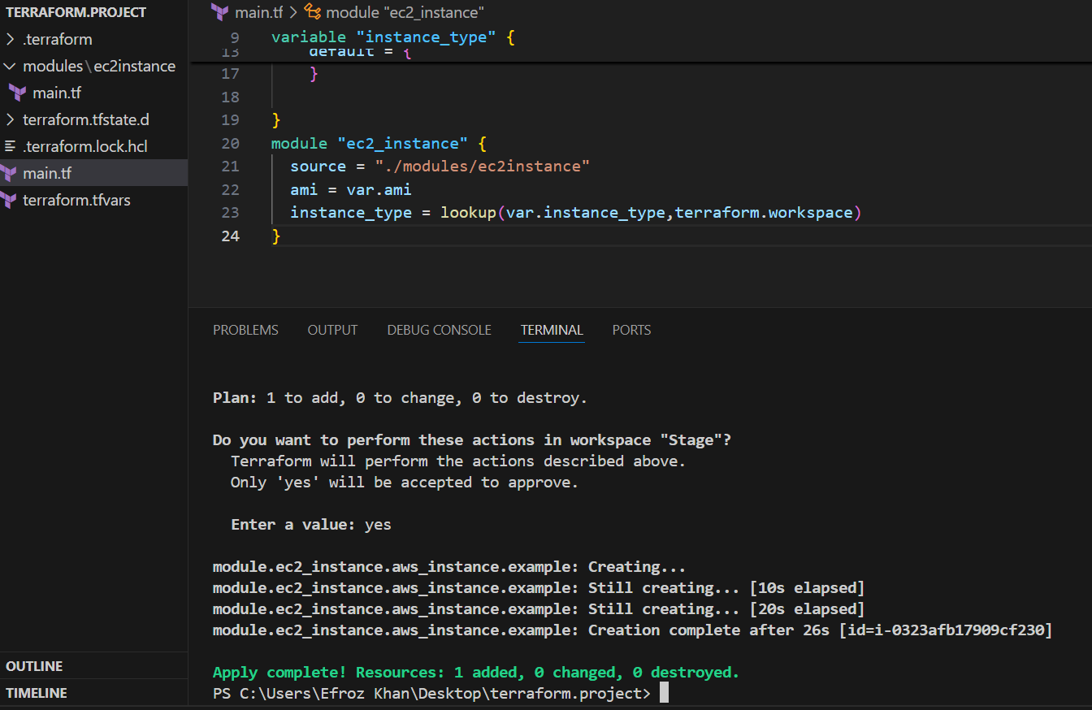

**Stage Environment OutPut:-**

C:\Users\Efroz Khan\Pictures\Screenshots\Screenshot 2024-07-25 175848.png

**Prod Work space Environment:-**

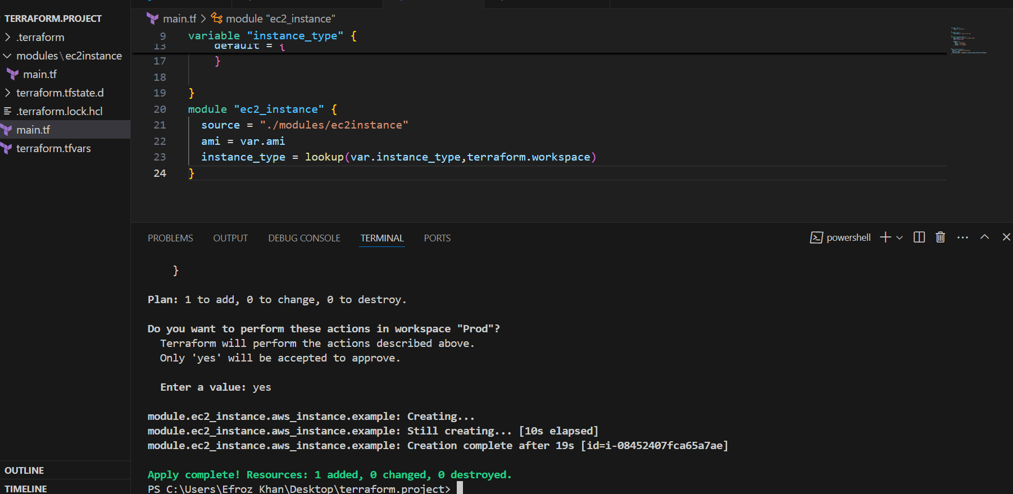

**Prod Workspace OutPut:-**

C:\Users\Efroz Khan\Pictures\Screenshots\Screenshot 2024-07-25 180033.png